**(ADDED to Paper)**

**Fire alarm batteries**

The battery that would be best for this SMART fire alarm system would be a 9V 1200mAh Lithium battery. The Ultra life 9V Lithium Battery is the perfect battery for low drain devices. Also, this battery has a long duration of shelf life at about 10 years, which is great for the fire alarm system. A long shelf life would help the fire alarm system be more reliable, and it will also require less maintenance. There are different types of batteries that we could use, alkaline or lithium batteries. As stated before, we chose to go with a lithium battery rather than an alkaline battery. When comparing the two different types of batteries we and see the difference between the two, and how we came to make this decision.

**Shelf-life**

When it comes to shelf life, we chose to go with the lithium battery because lithium batteries can last much longer than an alkaline battery can. As mentioned above a longer shelf live requires less maintenance to be done with the smoke detectors, other than routine checks to make sure that everything is up to code. Therefore, requiring less maintenance allows the customer to not have to change the battery so often.

**Performance**

Lithium batteries work well with devices that are low drain and high drain, whereas alkaline batteries don’t perform well with high drain devices, unless they are a special premium alkaline battery. Alkaline batteries are good batteries, just not for a smoke detector, a major problem with these types of batteries is that they are susceptible to self-discharging. This leakage could damage the device which could cause the smoke detector to malfunction and not go off which would endanger a lot of people. Lithium batteries are said to last about 7x to 8x longer than alkaline batteries. Also, it is mentioned that lithium batteries can withstand lower or higher temperatures depending on the environment that batteries are placed in. Opposed to alkaline batteries that can’t perform in those types of environments.

**Cost**

The upside that we found with the alkaline batteries is that they are very low cost, compared to lithium batteries, and you can get them in bundles for cheap as well. Lithium batteries are usually at least twice the amount of alkaline batteries. However, even though the lithium batteries are more expensive the quality of them are better and they outperform and outlast most other batteries. So, spending the extra money to purchase these types of batteries would be worth it so we could provide our customers with the best quality product.

**Power and Capacity**

Lithium batteries usually produce twice as much voltage as alkaline batteries produce, which allows them to outlast and have a longer shelf life as alkaline batteries. As mentioned above the Ultra life 9V lithium battery that we chose will have a max capacity rate of 1200mAh. Most alkaline 9V batteries don’t produce a max capacity rate of 1200mAh. Most of the alkaline batteries, besides the special premium types, produce around a max of 800mAh. With the lithium battery having a higher capacity rating than the alkaline battery this proves that the lithium battery will deliver a longer performance than the alkaline battery, which is what we want to provide a best quality product.

**Two sources of power vs. UPS**

Per the National Fire Alarm and Signaling Code a fire alarm system is required to have either a primary and secondary source of power or a single UPS, which is an Uninterruptable Power Supply. *“This requirement is to ensure that communications equipment will operate for the same period of time on the secondary power as the alarm control” – NFPA 72, A.26.6.3.1.12.* To be in accordance with the national code when having two sources of power the requirement is that the primary source has to be supplied by a dedicated branch circuit. However, that dedicated branch circuit doesn’t just have to be for servicing that one power supply it can also service multiple power supplies within a single control unit or multiple control units. The main purpose for this requirement is just to make sure that no other system is connected powered from that branch circuit. With a two-source power supply you can have batteries as a secondary source of power only, or you can have batteries as the primary source and have a backup generator as the secondary source of power. Although using two sources of power is still used the National Fire Protection Association (NFPA) has been pushing more to update them to an Uninterruptable Power Supply (UPS).

The purpose of a UPS system is to supply continuous power to the fire alarm system without having any interruptions when the primary power is off and the system is waiting for it to be restored, or until the backup power is online. There are two main types of UPS system, there is an offline UPS and an on-line UPS. Figures 1 and 2 below show both the block diagrams of the offline and online UPS systems.

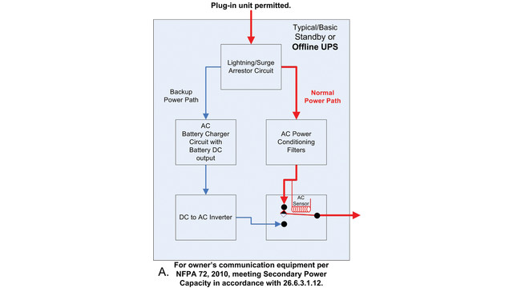Figure 1

Figure 1 shows how the offline uninterruptable power supply works. The initial path that is used to power the system is driven by an AC power source. An AC sensor is placed near the end of the path, and it is used as a function to switch between the two power sources when it senses that the primary power path has been interrupted. Once the system switches between the power sources, since the charged batteries are the secondary source of power within this system they will then be used to supply the power to the system until the primary source is back up and running.

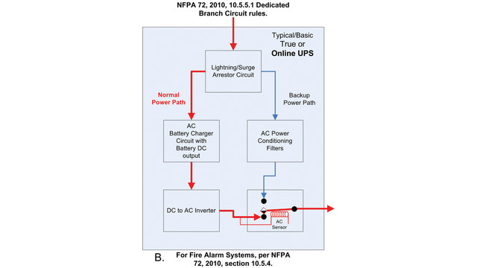Figure 2

Figure 2 shows how the online uninterruptable power supply works. With this type of UPS system, the initial path that is used to power the system is driven by a battery that is being charged as a primary power source for the system. At the end of this primary path a DC to AC inverter is implemented, and AC sensor is placed near the end of that path. As mentioned before it is used as a function to switch between the two power sources when it senses that the primary power path has been interrupted. For this type of online system since the charged batteries are the integral part of this type of UPS system and is the primary source of power within this system, the switching between the two paths is different from the switch in the offline UPS system. The ideal aspect about the online UPS system is that since it’s ran on batteries and a charger during the normal operation of the system, it can also still operate during a power outage simple because it is running off batteries and will only stop if there was failure within the pathway somehow. The only way the AC sensor will switch is if 1 out of the 3 things happen. 1.) The charger for the battery fails, 2.) The battery itself fails/dies, or 3.) The DC to AC invertor fails to work. Once one of these failures happen the sensor will switch to the secondary power source path, and it will be used to supply the power to the system until the primary source is back up and running.

The uninterruptable power supply systems, especially the online UPS system, is very ideal for our type of alarm system we are creating. Because it would provide the security that our product will perform properly even in an incident; for example, a power outage, and still having a system still running. Considering the two different types of methods of supplying power we could us we will be using two sources of power; the primary will be an AC power supply and the 9V battery mentioned above will be the secondary source we will be using.

**Fire alarm sound and signaling**

Per the National Fire Protection Association (NFPA 72) code, the audibility of the alarm varies depending on the type of environment the alarm system is in. For a public place the minimum audibility of the alarm must be 15dBA above the average ambient sound level, and for a private place the alarm cannot be less than 10dBA above the average ambient sound level. This is just one type of requirement for the audibility. Another one that pertains to both of the types of places is that the minimum requirement of sound from the alarm must be 5dBA above the max sound barrier with a duration of at least 60 seconds. Also, stated within the NFPA 72 code is that the maximum output audible sound the fire alarm system can have is 110dBA. This output is based upon the minimum hearing distance.

Based on the code requirements from the Nation Fire Protection Association, we could use this as reference guide in determining the type of component we will use for the fire alarm. As mentioned above the NFPA 72 code depending on the type of environment the system is in the audible sound level should either be 10dBA or 15dBA above the ambient noise level, or 5dBA for 60 seconds above the maximum level; with the alarm system being at a distance that is 5ft above the floor level. Table 1.1 shows the different locations, the average ambient noise level the minimum corresponding dBA level for an alarm system.

**Table 1.1**

|  |  |  |
| --- | --- | --- |
| Locations | Average ambient noise level (dBA) | Minimum required for SPL (dBA) per location |
| Business offices | 55 | 70 |
| Industrial occupancies | 80 | 95 |
| Institutional occupancies | 50 | 65 |
| Mechanical rooms | 85 | 100 |
| Places of assembly | 55 | 70 |
| Residential places | 35 | 50 |
| Storage occupancies | 30 | 45 |
| Thoroughfares, high-density urban areas | 70 | 85 |
| Thoroughfares, moderate – density urban areas | 55 | 70 |
| Thoroughfares, rural and suburban areas | 40 | 55 |
| Underground structures and windowless buildings | 40 | 55 |
| Educational occupancies | 45 | 60 |
| Mercantile occupancies | 40 | 55 |
| Piers and water-surrounded structures | 40 | 55 |
| Tower occupancies | 35 | 50 |
| Vehicles and vessels | 50 | 65 |

This table is in accordance with NFPA 72.

**Sounders**

When picking the type of sounders, we want to make sure we can reach a wide range of locations based off the min amount of audible sound. Per Chapter 18 of the NFPA 72 code the implementation of low frequency of 520 HZ must be used in in sleeping areas. So, to be able to comply with this code we wanted to make sure that we chose a sounder that would be able to work between a good range of frequencies that would cover both sleeping areas and normal occupancies. From this research, we came across many different types of sounders, but we narrowed it down 4 different types. Three are Piezo sounders and one is PUI programmable buzzer.

* **PS1927P02 Piezo sounder**

This sounder is a high sound pressure buzzer with a maximum SPL at 90dBA/10cm min at 2.7 kHz, at 10Vp rectangular wave. This sounder has a maximum input voltage at 20Vp (without a DC bias). Table 2.1 shows a graph of the sound pressure corresponding to frequency.

**Table 2.1**

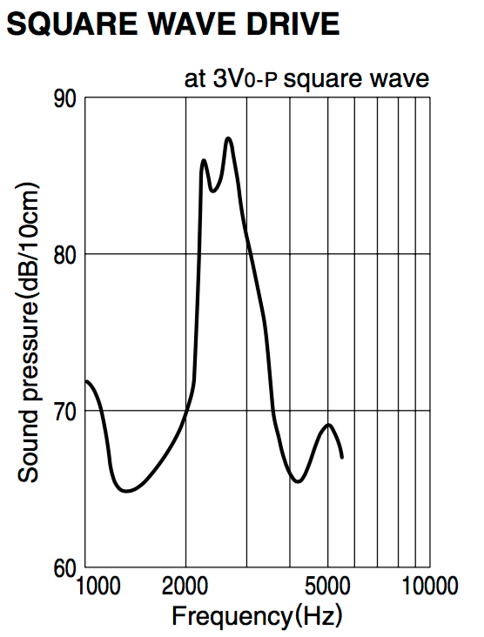

We considered this Piezo buzzer because the sound pressure level was high enough to where it would work in different types location specified in table 1.1. Also, the cost of this buzzer was cheap and would work with the budget. However, the SPL was only high between 2kHz and 3.5kHz, where at lower and higher frequencies the SPL was lower. So, this type of sounder didn’t give us a wider range frequencies to work with than the other buzzer types.

* **PS1920P02 Piezo sounder**

This sounder is a low frequency tone buzzer with a maximum SPL at 80dBA/10cm min at 2 kHz, at 10Vp rectangular wave. This sounder has a maximum input voltage at 20Vp (without a DC bias). Table 2.2 shows a graph of the sound pressure corresponding to frequency.

**Table 2.2**

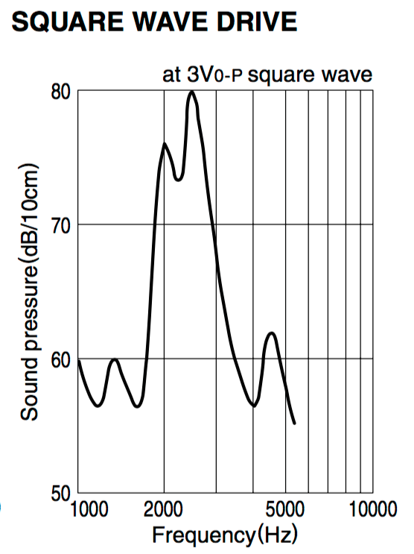

We considered this Piezo buzzer because the sound pressure level was high enough to where it would work in different types location specified in table 1.1. Also, the cost of this buzzer was cheap and would work with the budget. However, the SPL was only high between 2kHz and 3kHz. Also, this sounder had one of the lowest sound pressure level at the lower frequency than the other four sounders. As well as a low SPL at high frequencies. So, this type of buzzer didn’t give us a good range of frequency we could reach and still have a decent SPL that would work for different environments.

* **PS1740P02E Piezo sounder**

This sounder is a high sound pressure buzzer with a maximum SPL at 75dBA/10cm min at 4 kHz, at 3Vp rectangular wave. This sounder has a maximum input voltage at 30Vp (without a DC bias). Table 2.3 shows a graph of the sound pressure corresponding to frequency.

**Table 2.3**

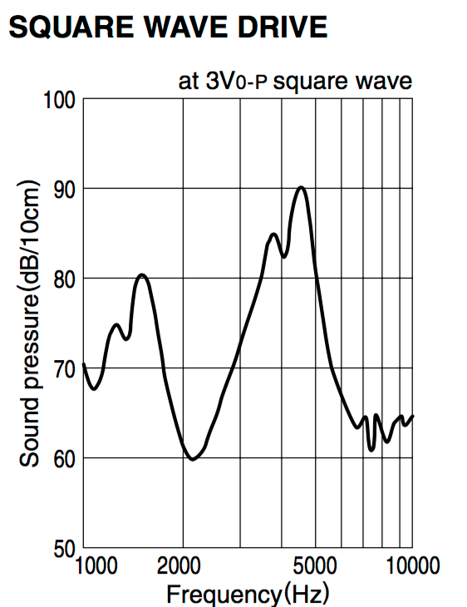

We chose this Piezo buzzer because the sound pressure level was high enough to where it would work in different types location specified in table 1.1. Also, the cost of this buzzer was cheap and would work with the budget. The frequency range that comes with this sounder is very broad which works well for this system. This sounder has a good sound pressure level with lower frequencies, which is good for private occupancies. As well as, a good sound pressure level with the higher frequency range that is good for public occupancies. Another reason as to why we chose this sounder is that the frequency gap where the SPL was low was smaller between the other buzzers. So, this sounder met a lot of specifications we needed so that is why we chose this one.

* **12 VDC PUI programmable buzzer**

This sounder is a high sound pressure buzzer with a minimum SPL at 100 dBA/10cm min at 1 kHz. This sounder has an operating voltage ranging from 7 – 24 Vdc, as shown as in the table below. Table 2.4 shows a specification table of the programmable sounder.

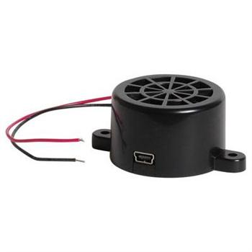

**Table 2.4**

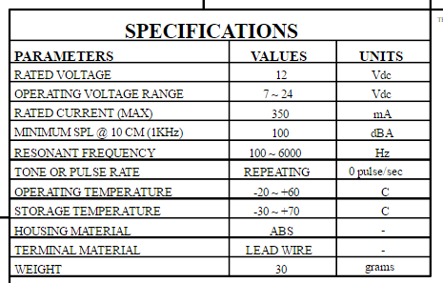

We consider this 12Vdc PUI programmable buzzer because the sound pressure level was high enough to where it would work in different types location specified in table 1.1. However, the cost of this buzzer was a lot more expensive than the other buzzer that we were considering, so due to the cost it would increase our budget more than we wanted it to, because we would need to buy several of them for the fire alarm system. The great thing about this buzzer is that it’s adjustable so we would be able to change the different types of sounds that it makes, and we would be able to adjust the sound pressure level. Even though the cost was high, the frequency range that comes with this sounder is very broad, as shown in the table above the resonant frequency range is from 100 Hz to 6 kHz; which works very well for this system. This sounder has a good sound pressure level with lower frequencies, and since it is adjustable it would work for private occupancies. As well as, a good sound pressure level with the higher frequency range that is good for public occupancies. So even though this sounder met a lot of specifications we needed, the cost and the SPL was a little bit too high for the use.

**Notification Appliances and Standards**

The National Fire Protection Association gives all the codes and standards of how alarm systems should run. When it comes to the how loud you need the alarm, the placement of the alarm, the amount of time the alarm and the duration of how long it should sound, also how the power supply should work. NFPA 72, 18.1.3 and 18.1.4 both mention what the requirements and standards are for the notification appliances for fire alarms. They state:

* *“The performance, location, and mounting of notification appliances used to initiate or direct evacuation or relocation of the occupants, or for providing information to occupants or staff…”- NFPA 72, 18.1.3.*
* *“The performance, location, and mounting of annunciators, displays, and printers used to display or record information for use by occupants, staff, responding emergency personnel, or supervising station personnel…”- NFPA 72, 18.1.4*

Section 18.4.2 of the NFPA 72 code states how distinctive the fire alarm evacuation signal should be, to be effective enough to warn the building occupancies when there is an emergency happening. Figure 3.1 shows the evacuation signal patter the fire alarm signal should follow.

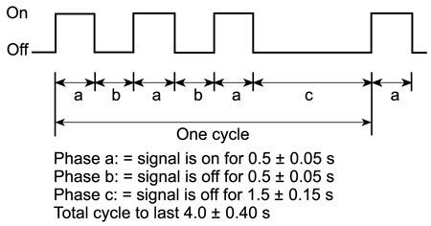

Figure 3.1

In figure 3.1 the (a) portion in the cycle is when the signal is in the “On” phase for .5 seconds. The (b) portion in the cycle is when the signal is in the “Off” phase for .05seconds. The (c) portion in when the signal is in the “Off” phase for 1.5 seconds. For the evacuation signal to comply with the code the whole entire cycle should last for total of 4 second and then repeat. Sections 18.4.2.3, 18.4.2.3.1, 18.4.2.3.2 in the NFPA 72 code state that:

* *“The signal shall be repeated for a period appropriate for the purposes of evacuation of the building, but for not less than 180 seconds.” – NFPA 72, 18.4.2.3*
* *“The minimum repetition time shall be permitted to be manually interrupted.” – NFPA 72, 18.4.2.3.1*
* *“The minimum repetition time shall be permitted to be automatically interrupted for the transmission of mass notification messages in accordance with chapter 24 (emergency communication systems)” – NFPA 72, 18.4.2.3.2*

In the sections 18.4.3 through 18.4.5 of the NFPA 72 code it states the standard for the noise level the alarm itself needs to produce when placed in a public occupancy, private occupancy, or a sleeping area. As mentioned in a previous section the sound level within in a public or sleeping area must be 15 dBA above the ambient sound level within the room, and the noise level must be 10 dBA above the ambient sound level when in a private occupancy. Within these different occupancies this is the standard for the sound level with the fire alarm system measured 5 ft. above the floor. The next section of this Chapter that was of importance to us was sections 18.5, 18.6, and 18.7. These sections described the visual characteristic the alarm system should produce. Visible signaling is very important when it comes to a fire alarm systems, because it is a way to signal to the occupants outside or within the building or structure. With the visual signaling the rate at which the flash must be at is extremely important. The code specifically states the rate at which the flash of the signal must be at.

* *“The flash rate shall not exceed two flashes per second (2 Hz) nor be less than one flash every second (1 Hz) throughout the listed voltage range of the appliance.” – NFPA 72, 18.5.3.1*
* *“The maximum lights pulse duration shall be 20 milliseconds with a maximum duty cycle of 40 percent.” – NFPA 72, 18.5.3.2*
* *“The pulse duration shall be defined as the time interval between initial and final points of 10 percent of maximum signal.” – NFPA 72, 18.5.3.3*

When considering the flash rate, you don’t want it to be too fast, but also you need to make sure that the flashes for each individual alarm are synchronized. The placement of the alarms is also important. Determining on the placement of each alarm within a building, it can make it seem that the flashes are not synchronized. What also needs to be taken into consideration is the color the visual signal will be, and the amount of brightness the light used for the visual signal will have. The placement, color, brightness, and the rate of the flash are important, because you also need to take in to consideration of some of the occupants in a building that may be photosensitive or that may have Epilepsy. Even though There isn’t a current law or standard that addresses this type of situation, it still needs to be taken into consideration so that you can ensure the safety of people. The NFPA 72 code does address the color the light for the signaling should be and the synchronization.

* *“Lights used for fire alarm signaling only or to signal the intent for complete evacuation shall be clear or nominal white and shall not exceed 1000 cd (effective intensity).” – NFPA 72, 18.5.3.4*
* *“Lights used to signal occupants to seek information or instructions shall be clear, nominal white, or other color as required by the emergency plan and the authority having jurisdiction for the area or building.” – NFPA 72, 18.5.3.5*
* *“The strobe synchronization requirements of this chapter shall not apply where the visible notification appliances located inside the building are viewed from outside of building.” – NFPA 72, 18.5.3.6*

Public occupancies and private occupancies share the same standards when it comes to the effectiveness and the intensity of the visible signal. However, sleeping areas are quite different because since a humans’ senses aren’t as alert. Depending on the height of the ceiling, and the distance the alarm is away from the pillow of the bed will determine the intensity of the noise of the alarm and the visible signaling as well. When it comes to the sound level of the alarm in in a sleeping area it is at the same level as it would be in a public occupancy, however the frequency of the signal is much lower. I study was done that more people who are asleep react and awaken to a lower frequency rather than at a higher frequency. That is why there is a requirement within the NFPA 72 code that the alarm system must work at a low frequency of 520 Hz when installed in a sleeping area. When it comes to the effective intensity of the visual signal in a sleeping area there are two different minimum values for the intensity of the visual. From the top of the pillow if the ceiling is less than or equal to 24 in (610 mm) than the minimum intensity level should be 110 cd. If the from the top of the pillow and the ceiling is greater than 24 in (610 mm) then the minimum intensity level of the visible signal must be 177 cd. Section 18.5.5.7.3 of the NFPA 72 code states:

*“For rooms with a linear dimension greater than 16 ft (4.87 m), the visible notification appliance shall be located within 16 ft (4.87 m) of the pillow.”*

What also comes into account when considering the visible signal of alarm systems is the corridor space. The dimensions of the space of the room determine the quantity of alarms that are needed to provide the correct amount of visible signals in a room to produce the alertness of an emergency. Table 3.1 will show the quantity of visible appliances required to be within a certain dimension per the NFPA 72 code.

**Table 3.1**

|  |  |
| --- | --- |
| **Room length (ft)** | **# of Visible Signals** |
| 0 – 30 | 1 |
| 31 – 130 | 2 |
| 131 – 230 | 3 |
| 231 – 330 | 4 |
| 313 – 430 | 5 |
| 431 - 530 | 6 |

This chapter within the National Fire Protection Association 72 code and standards is very crucial when designing a fire alarm system. If the specs and standards that are within this chapter aren’t done properly then you are risking the effectiveness of your system and diminishing it the systems efficiency. These standards are set to the minimum requirements for what a fire alarm system should meet to be able to perform. For a fire alarm system to perform efficiently and effectively it should be and exceed the standards set by the National Fire Protection Association. If this smart fire alarm system was produced on a much larger scale it will be very proficient. The specs of this smart fire alarm system meet every aspect within the codes; regarding the sound level component of the sounder and the visible signaling.

**Printed Circuit Board**

A printed circuit board (PCB) is a board made of 4 different types of materials; a silkscreen, soldermask, copper, and substrate. This board is mechanically used to support and electrically connect electrical components. For example, transistors, capacitors, resistors or any other active devices. These components are connected using conductive tracks, pads, and other features that are etched from copper sheets laminated onto a non-conductive substrate. The components that are connected on this board are usually soldered onto the board. Printed circuit boards are the backbones of all electronics devices. PCBs can be created any way you need it to be for a particular project or device. There is no specific design that must be followed when creating it. There are different types of software’s that you can use to create your own PCB board, or there are different companies that you can go through that make them, and they can create the design for you. PCBs can be either single layer, double layer, or multiple layers. Figure 4.1 shows the layout of the PDB board of a single layer and a double layer. This figure shows the composition of the PCB board; this figure does not show the silkscreen, but the silkscreen is just on top of the solder mask.

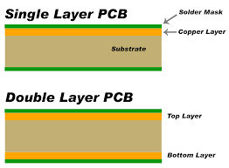

Figure 4.1 composition of PCB

**Silkscreen**

The silkscreen is usually used on the component side of the board to help identify different components, part numbers on the board, the test points, and other markings that are on the PCB board. When applying the silkscreen to the PCB you must consider the cost, because it can get expensive. For example, adding a second layer of silkscreen is double the original price, also added another color that isn’t one of the standard colors will cost extra. So, as you can see things can start to get more expensive the more you add. The conventional silk-screening of the PCB board requires polyester screens that are going to be stretched across and aluminum frame. When doing this silk-screening, certain equipment needs to be used for it. The type of equipment that is used is: laser photo plotter, which is used to produce the initial film that the silkscreen is on, UV printer, spray developer, and curing ovens. When also doing the silkscreen you also need to identify the type of “Ident” you want on the board. There are three different types of methods that are available to apply the Ident to the PCB.

* Manual screen-printing
  + This method is the most basic method that is used when printing the Ident.
* LPI (Liquid Photo Imaging)
  + This method provides more accurate and more legible letters than the manual screen.
* DLP (Direct Legend Printing)
  + This method id the most accurate and most legible printing of the letters than the two previous methods.

**Solder mask**

Solder pads are pads on the PCB board that have solder joint on them from being dipped in a solder pot. Solder bridges are electrical connections between two conductors that were unintended by a small piece of solder. To prevent solder bridges from happening on the PCB board solder masked are used. The solder mask is a thin lacquer-like layer of polymer that is usually applied to the copper traces of the PCB, which is for protection against oxidation and the help prevent solder bridges from forming between closely spaced solder pads. The solder mask layer is right under the silkscreen and right on top of the copper layer. The coating of the solder mask can also help prevent corrosion and electrical shorts from happening. In addition, the mask protecting from corrosion and shorts, it also works as an electrical insulation which will allow higher voltage traces to be placed closer to each other. Solder mask are very essential when it comes to mass production. However, it does make it easier and more efficient if you decide to solder by hand. The most common solder mask used is LPI (Liquid Photo Imaging), it is said that LPI mask are more reliable, accurate, and can make a better connection with the surface of the board and with the copper. Which this allows for better connection when soldering components.

**Copper**

This layer is the next layer after the solder mask. This layer is a thin piece of copper foil which is laminated to the board with heat and adhesive. The thickness of this copper slate is about 1oz, which is the standard internal layer copper thickness. The thickness and width of this copper slate on the printed circuit board is very important. The copper makes up the trace that is imprinted on the PCB, but these two factors determine the amount of current the circuit can carry. These two factors are also used in impedance calculations of high speed and RF circuitry. The base of the copper is usually measured by weight over one square foot Even though a lot of PCBs us 1 oz of copper per square foot, if the design is supposed to handle high power, then some designs will use between 2 oz to 3 oz. When added more weight to the base weight that is already attached to the PCB will cost more, because it will take more time for the manufacturer to produce it.

**Substrate**

The substrate which is the middle piece physically holds the circuit components and the traces, and provides and insulation between the conductive parts. The most common type of substrate used is a flame-resistant material FR-4. FR-4 is a fiberglass-epoxy laminate material. The FR-4 isn’t the only type of material used for a substrate; they can be made from Teflon, ceramics, and special polymers. There are five different types of substrate that each are unique and have their our set of characteristics:

* FR-2
  + This type is the lowest type of substrate to use. It is a paper material with phenolic binder.
  + This type of material is very inexpensive to use and is found in inexpensive consumer devices.
  + This material is also easy to machine over a fiberglass substrate.
* FR-4
  + This material is the most commonly used for a substrate, it is composed of glass fiber epoxy laminate.
  + Since fiberglass is very rigid this material can be cut, drilled, or machine
  + This material is of better and stronger quality than FR-2, and is more resistant to breaking or cracking.
  + Can be found in higher end electronics.
* RF
  + Used and can be found PCBs for high power radio frequencies.
  + Comprised of low dielectric plastics.
  + Works great with electrical performance properties, but lacks with mechanical properties.
* FLEX
  + This is a thin and flexible plastic, and this type of material is used as a substrate since it is flexible the circuit board can help save space within particular devices.
* Ceramic
  + This type of substrate is used for power electronics since they demand low- thermal resistivity.

Since the substrate is in between two conductive parts the PCB substrates does not conduct electrical current. Therefore, the substrates act as a laminated electrical insulator. The insulators internal electric charge does not flow freely, which is a good thing conduct under any influences. These different attributes add to this grade of a wide variety of electrical and mechanical appliances.